

**NAVIGATING YOUR WAY THROUGH EMPLOYEE ACCESS**

Employees may view additional tabs based upon the rights given to that employee.

**Employee Information**

Here employees will be able to view their personal information including, but not limited to, name, address, phone, emergency contacts, payroll and accounts payable check history, W2 history, W4 status, and direct deposit information. Employees will have the ability to request changes to such personal information including address, phone, email, emergency contact.

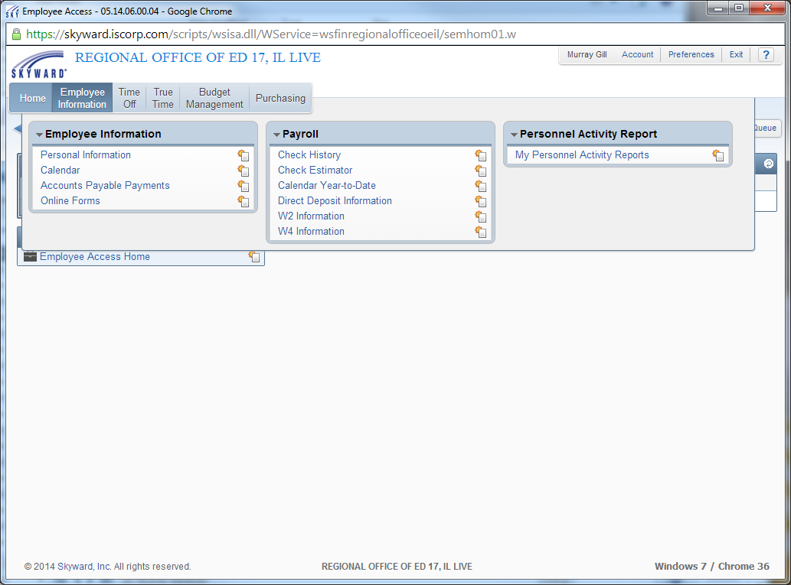

*\*Please Note that all fields will not be used by the ROE.*

**Time Off**

The Time Off Module is used for tracking all days off employee’s receive based on their employment status.

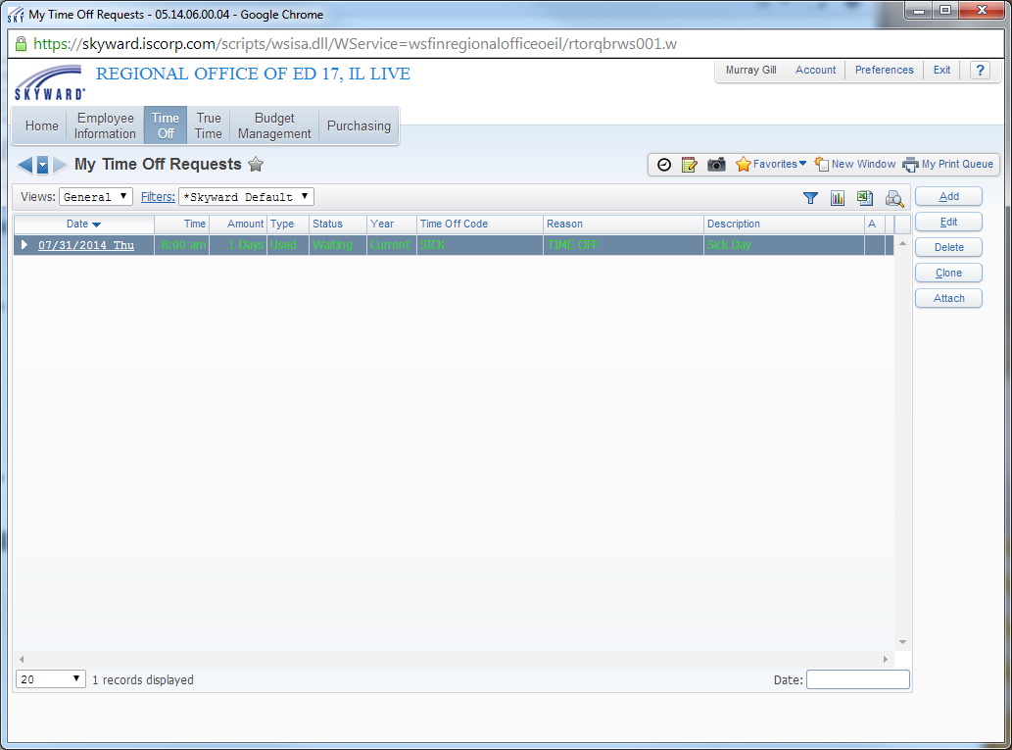To review your current requests and to add a new request click “My Requests”. All days submitted will be displayed in the window below. Within this window you can add, delete, and edit your days off requests. The “Clone” button will duplicate the current entry if only minor changes are necessary to your day off request.

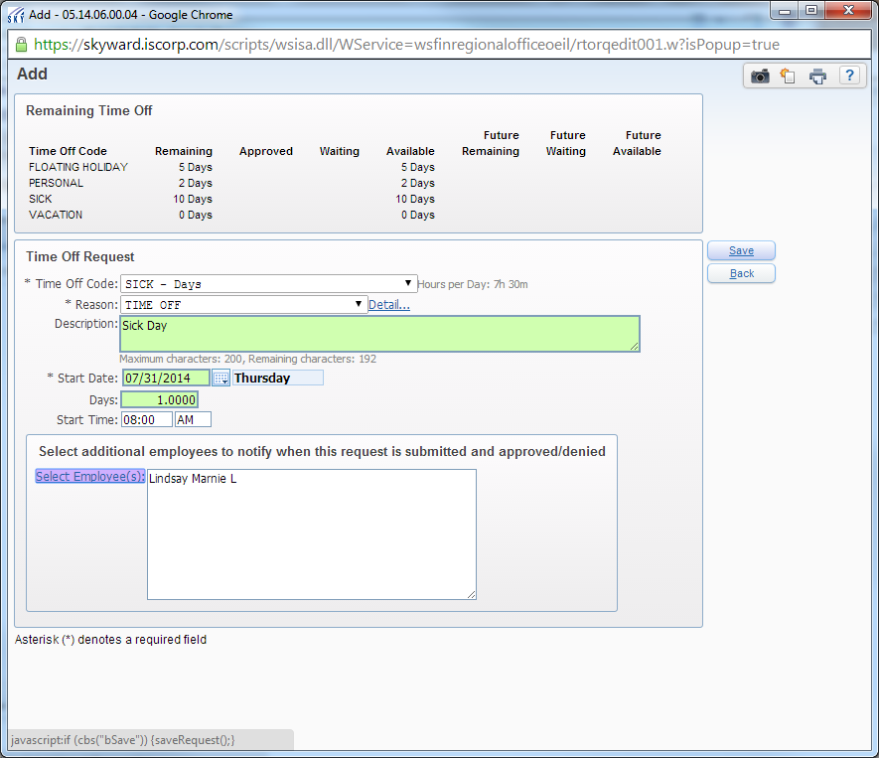Click “Add” to request a new day. The screen below will appear. Complete as needed and submit for approval by your supervisor. If you would like others in your department to be aware of your days requested, they may be added.

The status of your request can be seen on the “My Requests” screen under status.

**True Time**

Hourly employees will use True Time for tracking their daily time sheets. From this menu you will also have the ability to submit your weekly time sheets and run historical True Time Reports.

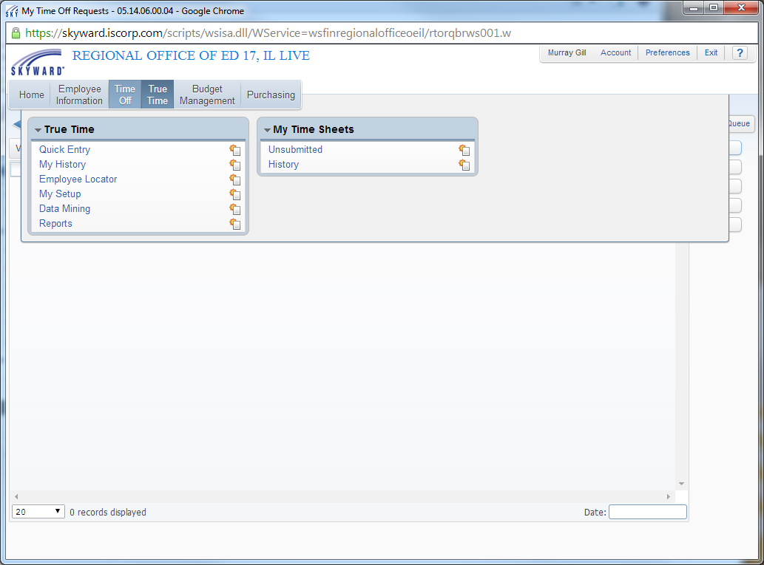

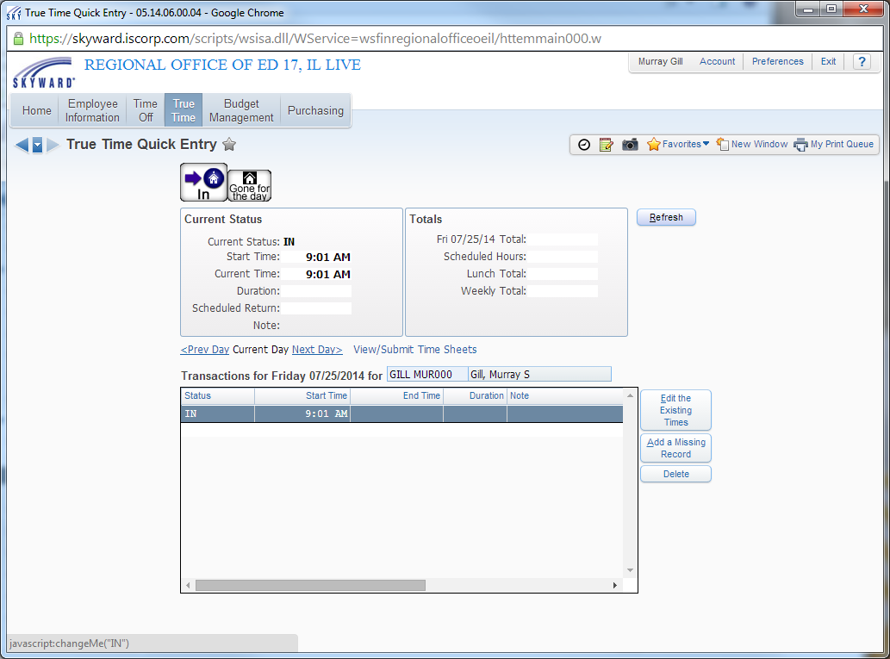

To enter your time click “Quick Entry”. Simply click the “In” or “Gone for the day” at the top of the screen to track your punches. Click “Edit Existing Times” if you need to adjust your current time. “Add a Missing Record” will be used to add any missed punches. To navigate through the days of the week click “Prev Day” or “Next Day”.

When all hours are entered for the week click “View/Submit Time Sheets”. Here you will be able to review your current time sheet before submitting to your supervisor for approval.

Times sheets must be submitted weekly by 11:59 pm Saturday.